|  |  |  |
| --- | --- | --- |
|  | **Scheda per la valutazione del dolore** | **Dati del paziente** Nome _______________________________ Cognome ___________________________  Data di nascita ____/____/______ Sesso M F |

Data ____/____/______

Diagnosi

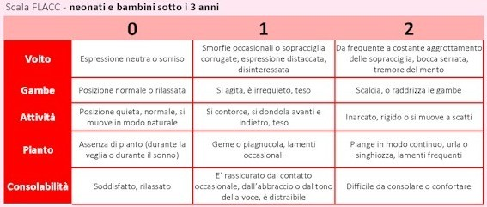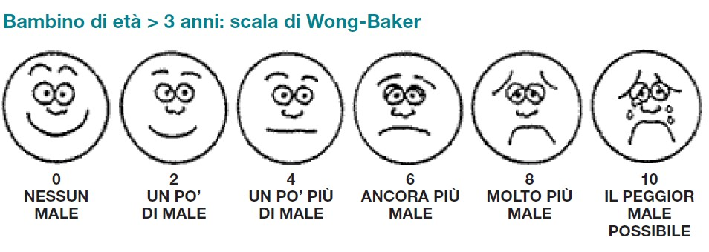

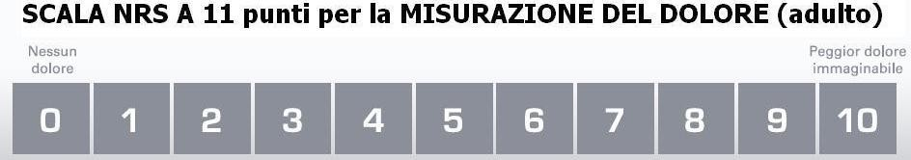



|  |  |  |  |  |  |  |  |  |  |
| --- | --- | --- | --- | --- | --- | --- | --- | --- | --- |
|  | **DATA**  *_____/_____/_____* | | | **DATA**  *_____/_____/_____* | | | **DATA**  *_____/_____/_____* | | |
|  |  | | |  | | |  | | |
|  | **08** | **15** | **21** | **08** | **15** | **21** | **08** | **15** | **21** |
| **NRS** |  |  |  |  |  |  |  |  |  |
| **Fc** |  |  |  |  |  |  |  |  |  |
| **Pa** |  |  |  |  |  |  |  |  |  |
| **Fr** |  |  |  |  |  |  |  |  |  |
| **SpO2** |  |  |  |  |  |  |  |  |  |
| **Sedazione** |  |  |  |  |  |  |  |  |  |
| **Cefalea** |  |  |  |  |  |  |  |  |  |
| **Nausea** |  |  |  |  |  |  |  |  |  |
| **Vomito** |  |  |  |  |  |  |  |  |  |
| **Altro** |  |  |  |  |  |  |  |  |  |
| **Firma** |  |  |  |  |  |  |  |  |  |

**RESCUE DOSE**

|  |  |  |  |
| --- | --- | --- | --- |
|  | **Farmaco e.v.** | **Anestetico locale** | **Altro** |
| **Data**  **____/____/____** |  |  |  |
| **Data**  **____/____/____** |  |  |  |
| **Data**  **____/____/____** |  |  |  |
| **Data**  **____/____/____** |  |  |  |
| **Data**  **____/____/____** |  |  |  |

|  |  |  |
| --- | --- | --- |
|  | **Avvisato Medico reparto** | **Avvisato anestesista** |
| **Data**  **____/____/____** |  |  |
| **Data**  **____/____/____** |  |  |
| **Data**  **____/____/____** |  |  |
| **Data**  **____/____/____** |  |  |
| **Data**  **____/____/____** |  |  |